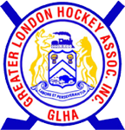
GLHA Agenda for
Oct 21, 2021 meeting

- Welcome/Call to Order
- Confirmation of Agenda
- Novice, Atom Pathways program Registration fee’s
- Initiation Games
- Select Program
- Goalies

- Approval of prior meeting minutes
- Reports;
  - Chairperson
  - Rep Council
  - London Referee Group
  - Treasurer
  - Technical Director
- Committee Reports;
  - Community Hockey League
  - Jr Mustangs
  - Championship
- Round Table/New Business
- Adjournment

